Note: IPv4 header is used in layer 3 to help send data between devices on separate networks,even on the other sides of the world over the internet,this is also known routing.
Note: IPv4 is used to encapsulate a tcp or udp segment.
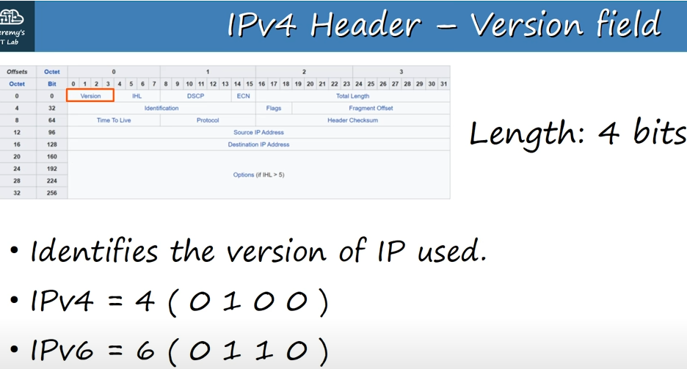

Version field
Note: There was an experimental protocol Internet stream protocol which uses internet protocol value of 5 ,but it was never publicly used.So we can say that is the lost IPv5.
Note: If the value of this field is 6,the rest of the header will also have a different structure.
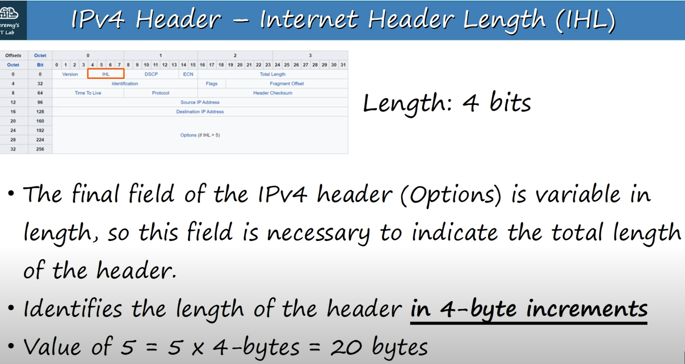

Internet Header Length(IHL)

Note: Third point is an example of identifying the length of the header in 4.-byte-increments(which is said in second point).
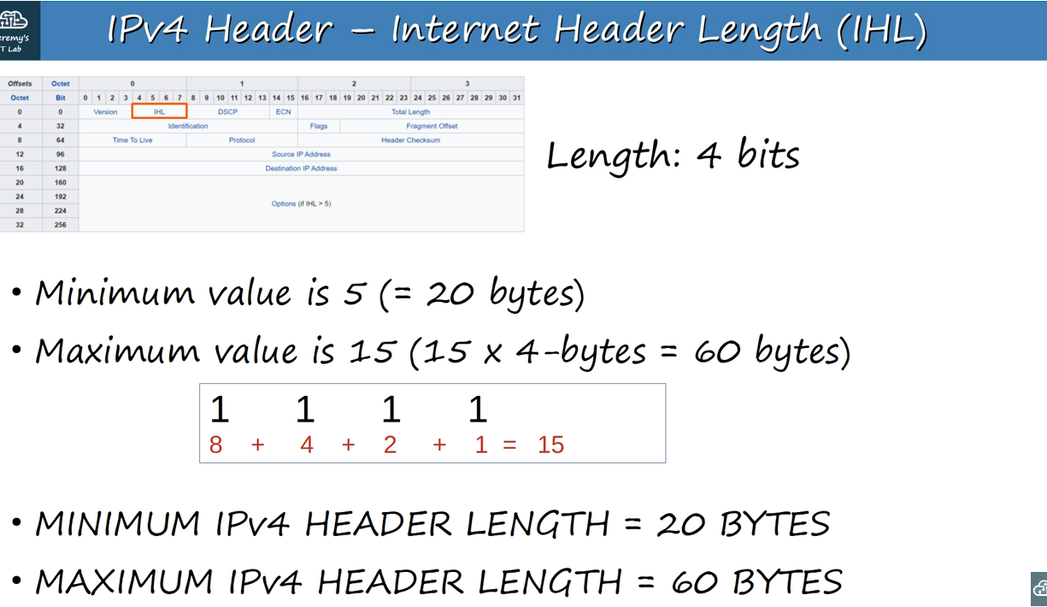

Note: Minimum value(5) is the length of IP packet without any options.So and empty options field.
Note: 1 1 1 1 means it says 15,which means packet is 60 bytes length
Note: Because maximum length is 60 and minimum length is 20,means that maximum length of options field is 40 bytes.
Note: So IP v4 header with no options field is 20 bytes in length.And IPv4 header with maximum options field length(40 bytes), has a length 60 bytes in length.
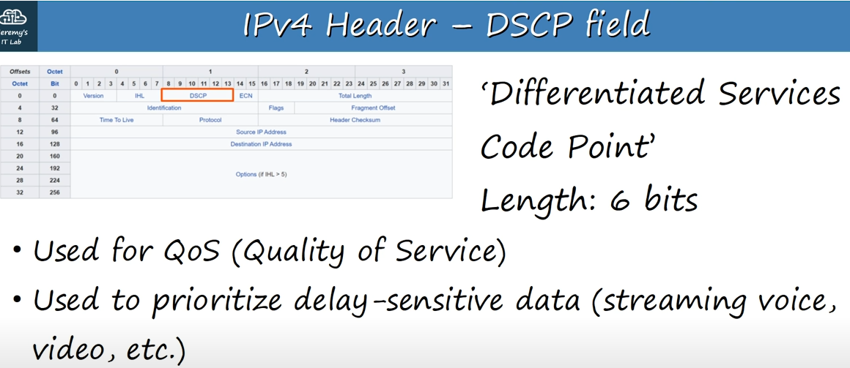

DSCP field
Note: If we are loading a webpage and the internet is little slow,it is not a big deal.But if we are having a skype call and there is a terrible delay or the audio or video keep freezing it can totally ruin the experience.This field is used to identify which traffic should receive priority treatment.

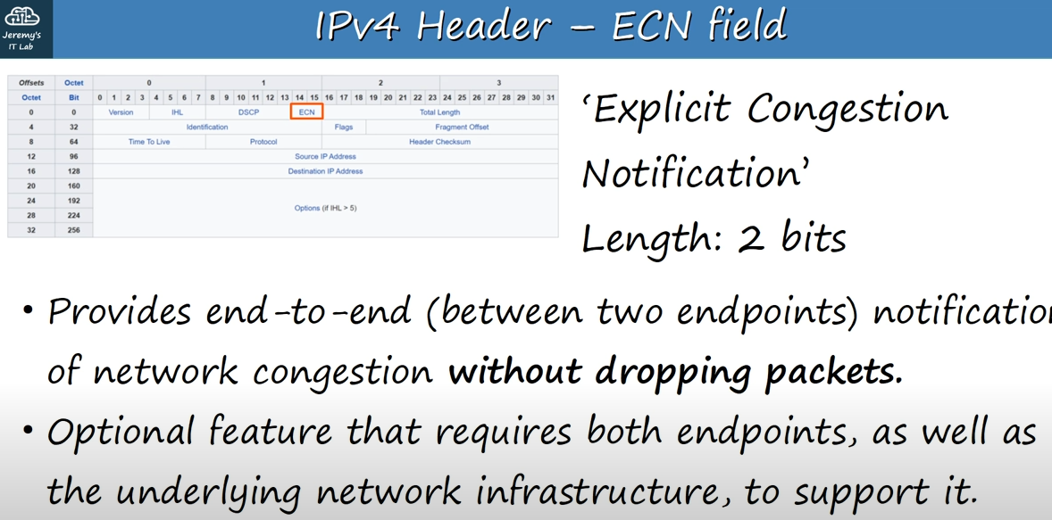
ECN field

ECN field
Note:Normally in a network,if the network is super busy,if there is congestion(скопление,затор,перезагрузка),this is signalled by dropping backets.The ECN field provides a way to signal a congested network without dropping packets.
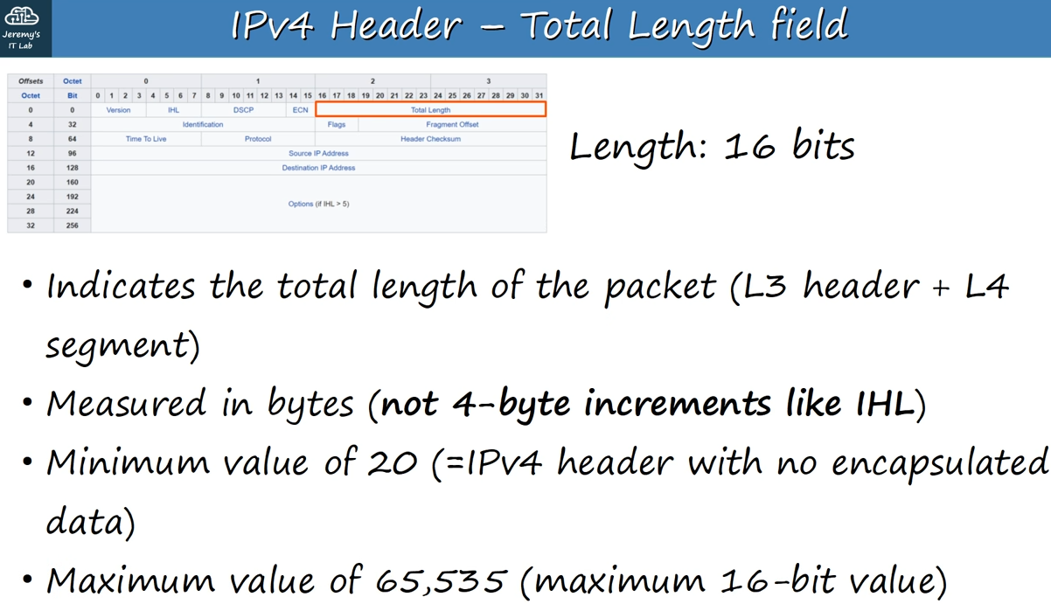

Total Length field
Note: This is different than the IHL field which indicates only the length of IPv4 header itself.
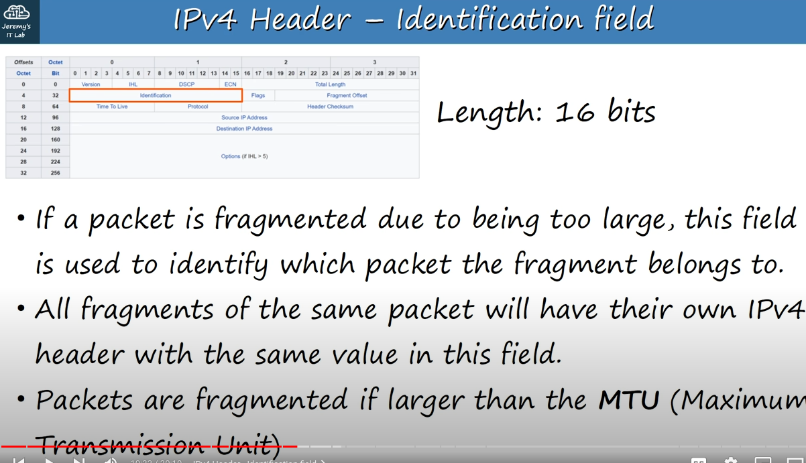

Identification field
Note:(in addition to second point)So we can reassembled again to make the original packet.
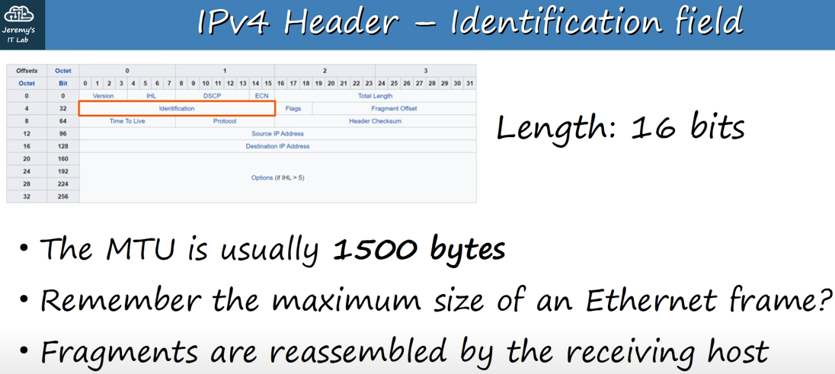

Note: (in addition to second point) Maximum payload size of an ethernet frame is 1500 bytes,so these are related.
Note: Fragments are also packets.
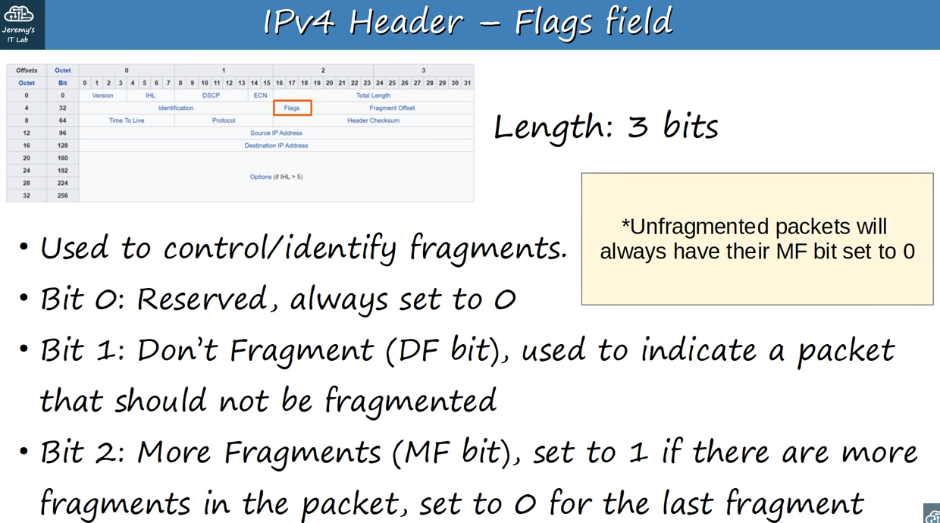

Flags field
Note (Chat gpt answer)The purpose of the first bit in the IPv4 "Flags" field is to be reserved for future use. It is currently unused and always set to 0 to ensure compatibility and proper functioning of the protocol. In general, reserved bits in protocol headers are placeholders that may be utilized in future versions of the protocol for additional features or functionality.
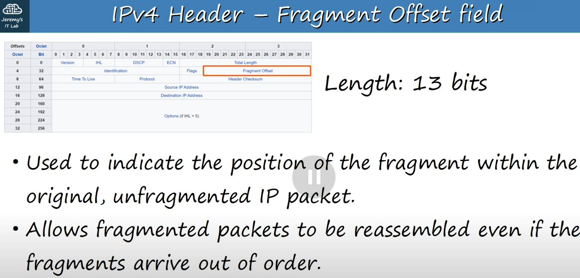
Fragment Offset field
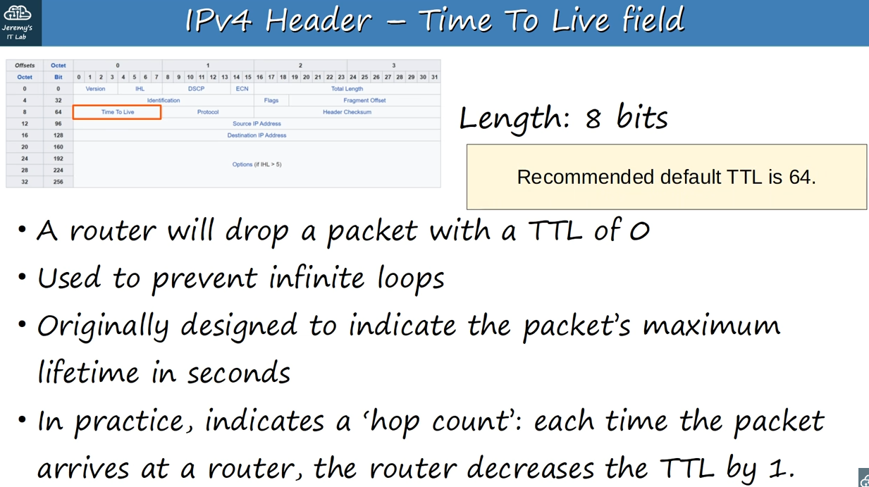

Time To Live field
Note: (in addition to second point) If a poor routing configuration causes a packet to be continually sent around in a loop,never reaching it’s intended destination,if enough traffic like that accumulates,it could cause network congestion,and eventually failure.This feature prevents that from happening,causing looped traffic to be dropped when the TTL reaches.
Note: (in addition to third point) Each time it arrives at a router on it’s way to its destination,the TTL is decreased by one ,unitl it reaches it’s destination or the TTL reaches 0 and the packet is dropped.
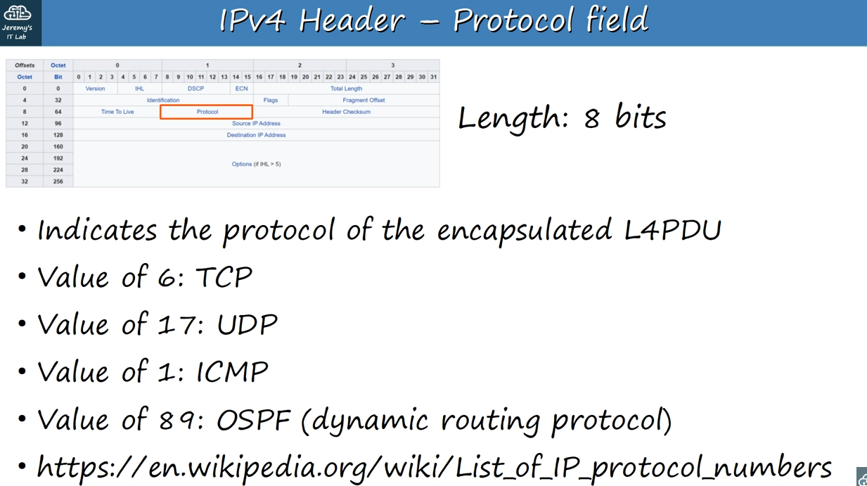
Protocol field
Note: L4PDU=Layer 4 PDU
Note: OSPF = open shortest path first.OSPF is a dynamic routing protocol which allows routers to learn routes to destinations from their neighbors,without us having to manually configure the routes.
Note: Protocol list on wikipedia(last point)
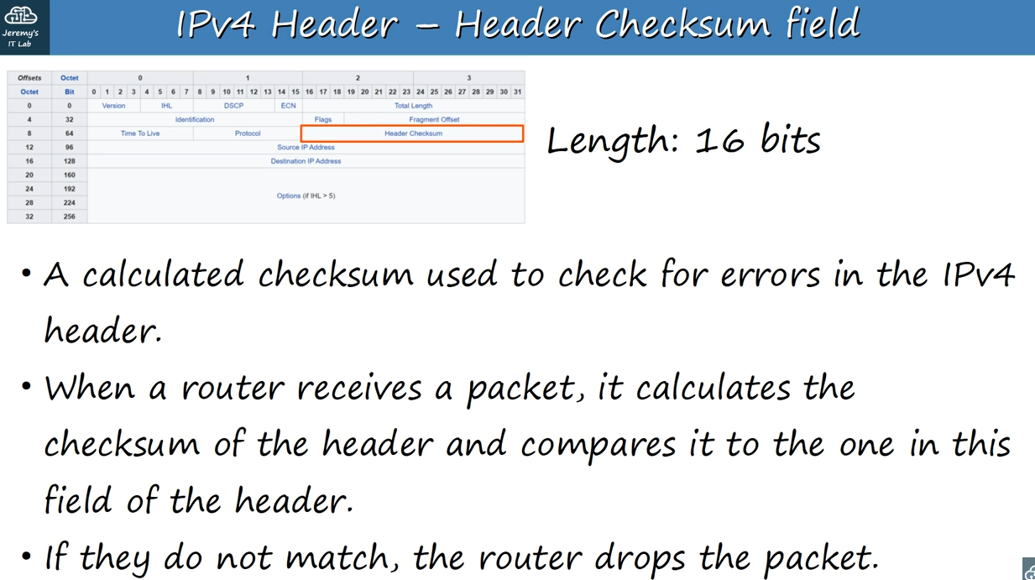
Header checksum field

Note:(in addition to third point) If the newly calculated checksum and the checksum in IPv4 header do not match,it means that an error occurred in transmission so the router drops the packet.
Note: This is only used to check for errors in the IPv4 header,not in the encapsulated data.
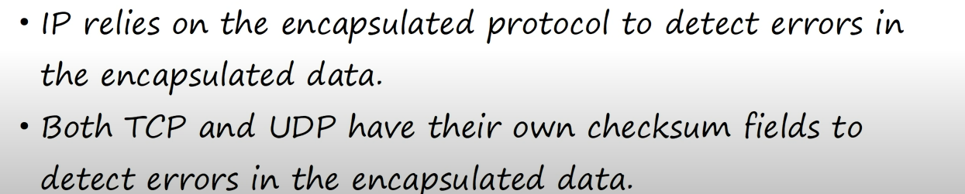
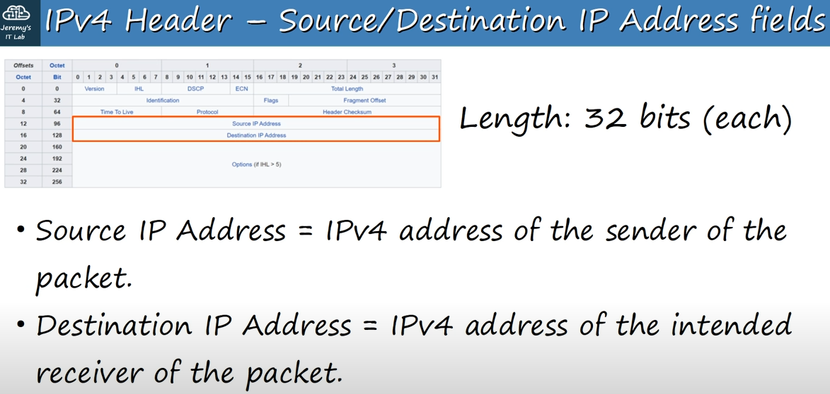
Source/Destination IP address fields

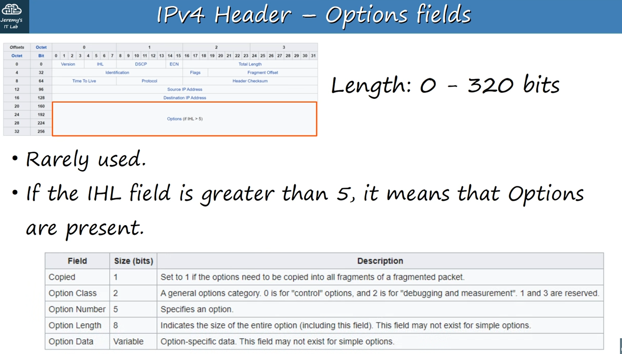

Options fields

Wireshark packet caputre

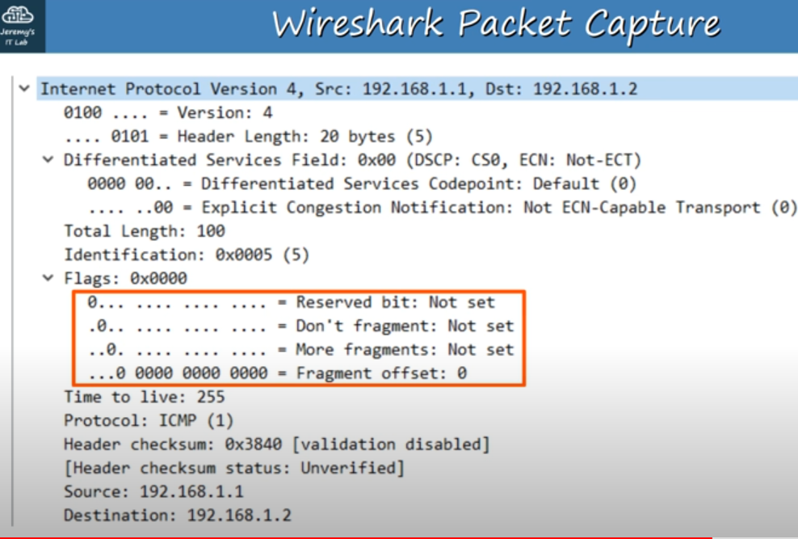

IPv4 header section
Note: In any of first three sections(Reserved bit…) in Flags field, if it is set,that bit will be 1,otherwise 0.
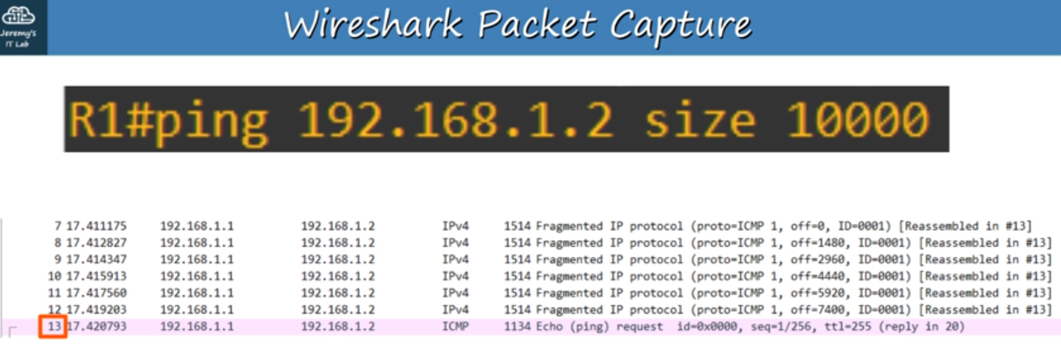
Pinging 10000 bytes,which will be fragmented

Note: reassembled in #13 means that they will be reassembled in 13(highlighted in square box),which is ICMP echo request.
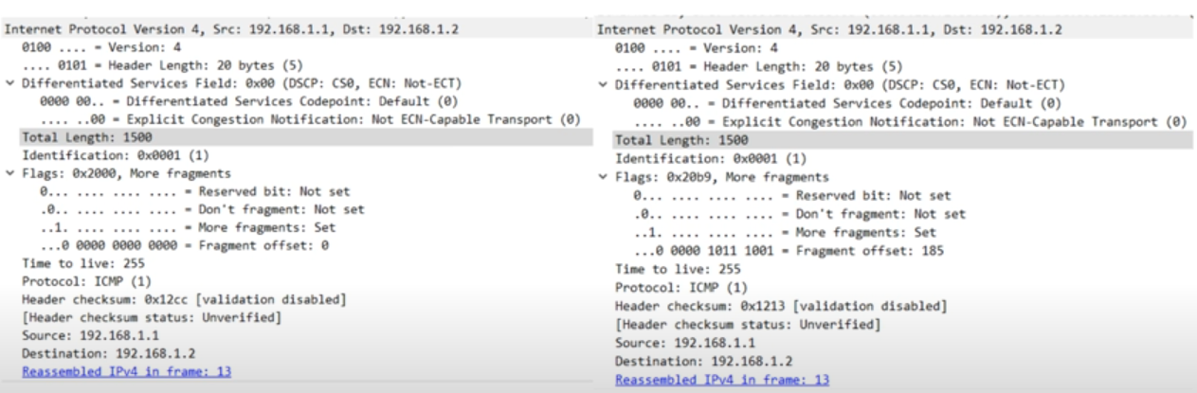
Details of first two fragments

Note: Total length of two fragments are 1500 bytes each,so this 10000 bytes ping was divided up into 1500 byte fragments,which is equal to MTU size
Note: Each fragment has MF(More fragments) set to 1 because neither of these is the last packet in t he fragment.
Note:Each of them has different fragment offset value,and the first fragment has an offset of 0.

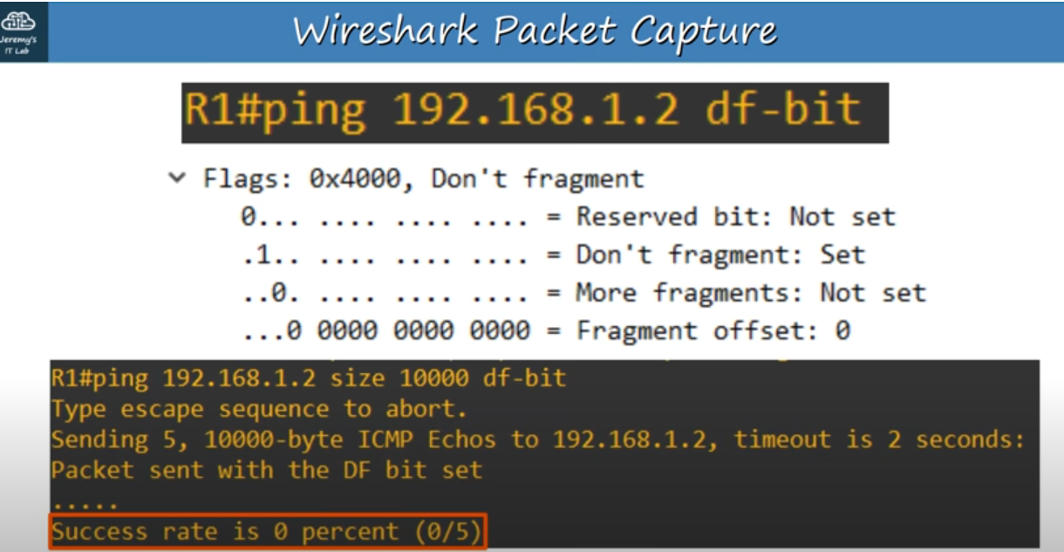

Sending a ping,and set the DF(Don’t fragment) bit to 0,with ping <IP address> df-bit
Note: In first case(on top,100 byte ping) it worked well, but when we sent a 10000 bytes ping,which is larger than MTU and set the DF bit,the ping failed,because it was too large to be sent unfragmented,but also not allowed to be fragmented.

